using System;

namespace backendDay3

{

class Student

{

public string name;

public int age;

public string academicGrade;

public void displayDetails()

{

Console.WriteLine("Name\tAge\tAcademic Grade");

Console.WriteLine(name + "\t" + age + "\t" + academicGrade);

}

}

internal class Program

{

static void Main(string[] args)

{

bool valid;

Student student1 = new Student();

Student student2 = new Student();

Student[] students = { student1, student2 };

for (int i = 0; i < students.Length; i++)

{

Console.WriteLine($"\nEnter the details of Student #{i + 1}");

Console.Write("Name: ");

students[i].name = Console.ReadLine();

valid = false;

while (!valid)

{

Console.Write("Age: ");

if (int.TryParse(Console.ReadLine(), out students[i].age))

valid = true;

else

Console.WriteLine("Please insert a valid input. Try again");

}

Console.Write("Academic Grade/Level: ");

students[i].academicGrade =Console.ReadLine();

}

Console.WriteLine("\n--- Student Information ---");

foreach (Student s in students)

{

s.displayDetails();

Console.WriteLine();

}

}

}

}

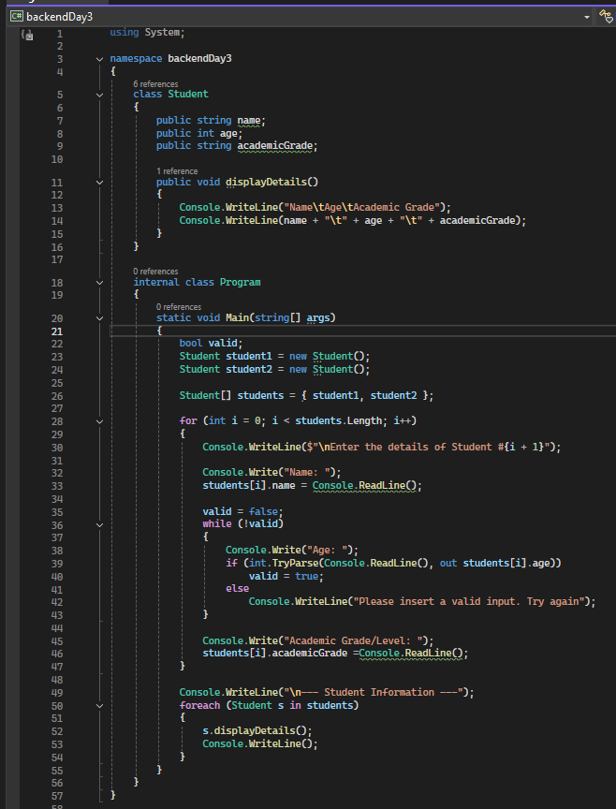

**OUTPUT**

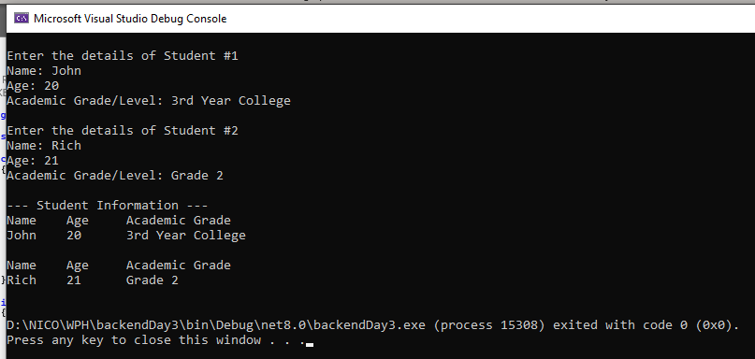

**ERROR HANDLING**

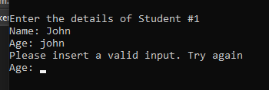

**EXPLANATION**

I made a class to represent a student, with fields for name, age, and academic grade. Then I created two student objects and stored them in an array so I could use a loop to get their info. I used Console.ReadLine() to ask the user to input each student’s details and saved that data into the object’s fields. After that, I used a foreach loop to call a method from the class to display the student info on the screen. I didn’t use private or encapsulation to keep things simple, so I could access the fields directly. I learned how to create and use classes and objects in C#, how they help organize data better, and how different access modifiers have different purposes and uses.